Research Methods Workshop

Partial Least Squares Structural Equation Modelling (PLS-SEM) Using SmartPLS 3

Instructors
Dr. Christian M. Ringle, Professor of Management,
Hamburg University of Technology (TUHH), Germany, and University of Waikato, New Zealand
Christian M. Ringle is a Chaired Professor of Management and the Director of the Institute of Human Resource Management and Organizations (HRMO) in the Department of Management Sciences and Technology at the Hamburg University of Technology (TUHH), Germany, and a Conjoint Professor of the Waikato Management School, New Zealand.

He holds a PhD from the Faculty of Business and Economics at the University of Hamburg. Amongst other research stays and appointments, Ringle was a visiting researcher at the Georgia State University and the Osaka City University and he was a Conjoint Professor at the University of Technology Sydney and the University of Newcastle in Australia.

His research addresses human resource management, organization, marketing, strategic management, and quantitative methods for business and market research. His contributions in these fields have been published in journals such as International Journal of Research in Marketing, Information Systems Research, Journal of Business Research, Journal of Leisure Research, Journal of Service Research, Journal of the Academy of Marketing Science, Long Range Planning, MIS Quarterly, and Tourism Management. Moreover, Christian is a co-author of two textbooks on the PLS-SEM method and a co-developer of the SmartPLS software program. Recently, he has been included in the 2018 and 2019 Clarivate Analytics' Highly Researchers list. He regularly teaches doctoral seminars on multivariate statistics, especially the PLS-SEM method, and the use of the statistical software.

- More information on Christian M. Ringle and his list of publications: http://www.tuhh.de/hrmo/team/prof-dr-c-m-ringle.html
- Google Scholar: https://scholar.google.de/citations?user=y5F176wAAAAJ&hl=de
- Email: c.ringle@tuhh.de

Dr. Marko Sarstedt, Professor of Marketing
Otto-von-Guericke University Magdeburg, Germany, and Monash University Malaysia, Malaysia

Marko is a Chaired Professor of Marketing at the Otto-von-Guericke-University Magdeburg (Germany) and an Adjunct Professor at Monash University Malaysia. His main research interest is the advancement of research methods to further the understanding of consumer behavior. His research has been published in Nature Human Behaviour, Journal of Marketing Research, Journal of the Academy of Marketing Science, Multivariate Behavioral Research, Organizational Research Methods, MIS Quarterly, and Psychometrika, among others. According to the 2019 F.A.Z. ranking, he is among the three most influential researchers in Germany, Austria, and Switzerland. Marko has been named member at Clarivate Analytics’ Highly Cited Researchers List, which includes the “world’s most impactful scientific researchers.”

- More information on Marko and his list of publications: http://www.marketing.ovgu.de/marketing/en/Team/Head+of+the+Chair-p-966.html
- Google Scholar https://scholar.google.de/citations?user=KnnmEP4AAAAJ&hl=de
- Email: marko.sarstedt@ovgu.de

Goal and overview
This six-part online course participants to the state-of-the-art of partial least squares structural equation modeling (PLS-SEM) using the SmartPLS 3 software. The first day of the course provides a profound introduction to PLS-SEM. Participants will learn the foundations of PLS-SEM and how to apply it by means of the SmartPLS 3 software. The course continues with advanced topics including mediation, moderation, higher-order models, and the importance-performance map analysis (IPMA). At the end of the course, a live (online) wrap-up session includes case study exercises, questions and answers, and an outlook on additional advanced topics.

The relevance of PLS-SEM in business research
PLS-SEM is a composite-based approach to SEM, which aims at maximizing the explained variance of dependent constructs in the path model. Researchers and practitioners use PLS-SEM especially when they conduct studies on success factors and the sources of competitive advantage.
Compared to other SEM techniques, PLS-SEM allows researchers to estimate very complex models with many constructs and indicator variables. Furthermore, PLS-SEM allows to estimate reflective and formative constructs and generally offers much flexibility in terms of data requirements. The goal of PLS-SEM is the explanation of variances (prediction-oriented character of the methodology) rather than explaining covariances (theory testing via covariance-based SEM, CB-SEM). The application of the PLS-SEM method is of high interest if the assumptions of CB-SEM are violated and the proposed cause-and-effect relationships are not sufficiently explored. An additional advantage of the PLS-SEM method is the unrestricted inclusion of latent variables in small to very complex path models that draw on either/both reflective or formative measurements models. PLS-SEM has received considerable attention in a variety of disciplines (e.g., Ali, Rasoolimanesh, Sarstedt, Ringle, & Ryu, 2018, Khan, Sarstedt, Shiau, Hair, Ringle, & Fritze, 2019, Nitzl & Chin, 2017, Ringle, Sarstedt, Mitchell, & Gudergan, 2020), which resulted in several highly cited publications (e.g., Web of Science).

Who should attend?
This online course has been designed for full-time faculty and PhD/DBA doctoral students who are interested in learning how to design their research towards more rigorous and publishable outputs that potentially survive the test of time and are more frequently read and cited. A basic knowledge of univariate and multivariate statistics and SEM techniques is helpful and priority will be given to researchers with this basic knowledge.

Learning outcomes
This online course is designed to look at the stages of research question development and theorizing together with the subsequent methodological implementation using the multivariate analysis method PLS-SEM in business and management research. The learning objectives are to (1) contribute to theory by establishing a useful PLS path model, (2) develop an in-depth methodological appreciation of the PLS-SEM approach (the nature of theoretical modelling, analytical objectives, and related statistics), (3) acquire knowledge to evaluate measurement results, and (4) understand complementary analytical techniques.
Specifically, following the workshop participants will understand the following topics:
- Model development and fundamentals of PLS-SEM.
- PLS path model estimation.
- Assessment and reporting of measurement and structural model results including Bootstrapping.
- New criteria for model assessment such as HTMT for discriminant validity and goodness of fit (e.g., SRMR).
- Prediction-oriented results analysis including Blindfolding and PLSpredict.
- Higher-order constructs (e.g., second-order models).
- Mediating effects.
- Moderating effects (interaction effects).
- Importance-performance map analysis (IPMA) of PLS-SEM results.

In addition, the participants will be able to use the SmartPLS 3 software for their PLS-SEM analyses.

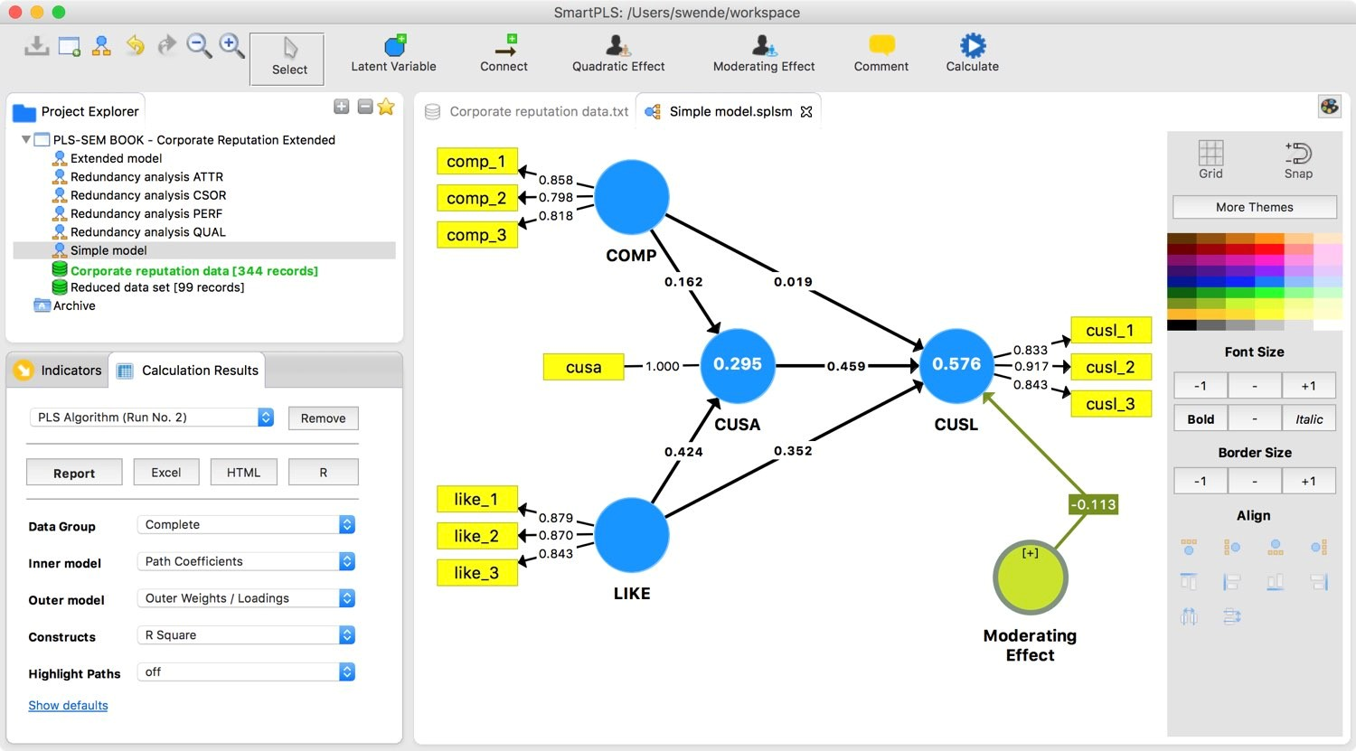

Teaching and learning methods
- Online lectures/presentations: The sessions will cover theory and its application.
- Computer exercises use the latest SmartPLS 3 version: Specifically, theoretical explanations underlying the software procedures and practical exercises where participants will apply their learning to real-world examples provided by the instructor.
- Download and install the SmartPLS 3 software from http://www.smartpls.com before coming to the workshop (participants will receive detailed instructions shortly before the course starts)
- All participants will get a 60-days license for SmartPLS 3 Professional.
- All participants receive course certificates after successful completion of online quizzes.

Teaching resources

Books on PLS-SEM
Hair, Joseph F., G. Tomas M. Hult, Christian M. Ringle, and Marko Sarstedt (2017), A primer on partial least squares structural equation modeling (PLS-SEM) (2nd ed.). Thousands Oak, CA: Sage Publications.
Hair, Joseph F., Marko Sarstedt, Christian Ringle, and Siegfried P. Gudergan (2018), Advanced issues in partial least squares structural equation modeling. Thousands Oaks, CA: Sage Publications.

Software
Ringle, Christian M., Sven Wende, and Jan-Michael Becker (2015), "SmartPLS 3." Bönningstedt: SmartPLS.

Additional recommended readings
- Khan, Sarstedt, Shiau, Hair, Ringle, and Fritze (2019). Methodological Research on Partial Least Squares Structural Equation Modeling (PLS-SEM): An Analysis Based on Social Network Approaches. Internet Research, 29(3), 407-429.
- Sarstedt, Ringle, and Hair (2017). Partial Least Squares Structural Equation Modeling. In Homburg, Christian, Martin Klarmann, & Arndt Vomberg, (Eds.), Handbook of Market Research. Cham: Springer.
- Hair, Risher, Sarstedt, and Ringle (2019). When to Use and How to Report the Results of PLS-SEM. European Business Review, 31(1), 2-24.
- Sarstedt, Hair, Jun-Hwa, Becker, and Ringle (2019). Structural Model Robustness Checks in PLS-SEM. Tourism Economics, forthcoming.
- Ringle and Sarstedt (2016). Gain More Insight from Your PLS-SEM Results: The Importance-Performance Map Analysis. Industrial Management & Data Systems, 116(9): 1865-86.
- Henseler, Ringle, and Sarstedt (2015). A New Criterion for Assessing Discriminant Validity in Variance-based Structural Equation Modeling. Journal of the Academy of Marketing Science, 43(1): 115-35.
- Nitzl, Roldán, and Cepeda Carrión (2016). Mediation Analysis in Partial Least Squares Path Modeling: Helping Researchers Discuss More Sophisticated Models. Industrial Management & Data Systems, 119(9): 1849-64. Becker, Ringle, and Sarstedt (2018)Becker, Ringle, and Sarstedt (2018)Becker, Ringle, and Sarstedt (2018)
- Becker, Ringle, and Sarstedt (2018). Estimating Moderating Effects in PLS-SEM and PLSc-SEM: Interaction Term Generation*Data Treatment. Journal of Applied Structural Equation Modeling, 2(2): 1-21.
- Sarstedt, Hair, Ringle, Thiele, and Gudergan (2016). Estimation Issues with PLS and CBSEM: Where the Bias Lies! Journal of Business Research, 69(10): 3998-4010.

More PLS-SEM literature and publications:
- https://www.smartpls.com/documentation
- https://www.tuhh.de/hrmo/team/prof-dr-c-m-ringle.html

Tentative schedule
 | Content
Part 1 | PLS-SEM: A comprehensive introduction  Everything you need to know about the principles of PLS-SEM  https://www.pls-sem-academy.com/p/pls-sem-a-comprehensive-introduction  Key benefits:  - More than four and a half hours of video material  - Covers the latest developments in PLS-SEM  - Comprehensive lecturing slides included  - Annotated outputs from SmartPLS illustrate all analyses step-by-step  - Personalized certificate after successful completion of the final exam
Part 2 | Mediator analysis  Understand mediator analysis and learn its execution in PLS-SEM  https://www.pls-sem-academy.com/p/mediator-analysis  Key benefits:  - Comprehensive video material discussing mediation and its implementation in PLS-SEM  - Covers advanced topics such as parallel and serial mediating effects  - Comprehensive lecturing slides included  - Annotated outputs from SmartPLS illustrate all analyses step-by-step  - Certificate after successful completion of the final exam
Part 3 | Moderator analysis  Understand moderator analysis and learn its execution in PLS-SEM  https://www.pls-sem-academy.com/p/moderator-analysis-in-pls-sem  Key Benefits  - Comprehensive video material discussing moderation and its implementation in PLS-SEM  - Covers the latest research on model specification  - Comprehensive lecturing slides included  - Annotated outputs from SmartPLS illustrate all analyses step-by-step  - Certificate after successful completion of the final exam
Part 4 | Higher-order models  Learn how to specify, estimate, and validate higher-order models in PLS-SEM  https://www.pls-sem-academy.com/p/higher-order-models  Key Benefits  Comprehensive video material covering the state-of-the art in higher-order modeling  Offers clear guidelines for specifying, estimating, and validating higher-order models  Comprehensive lecturing slides included  Annotated outputs from SmartPLS illustrate all analyses step-by-step  Certificate after successful completion of the final exam
Part 5 | Importance-performance map analysis (IPMA)  Everything you need to know about the IPMA  https://www.pls-sem-academy.com/p/importance-performance-map-analysis-ipma  Key benefits  - Comprehensive video material covering the state-of-the-art in importance-performance map analysis (IPMA)  - Learn how to carry out and to interpret the results of an IPMA on the construct and item level  - Comprehensive lecturing slides included  - Annotated outputs from SmartPLS illustrate all analyses step-by-step  - Personal certificate after successful completion of the final exam
Part 6 | Live wrap-up session:  - Case study example using SmartPLS 3  - Questions and answers  - Outlook on advanced PLS-SEM topics

Literature
Ali, F., Rasoolimanesh, S. M., Sarstedt, M., Ringle, C. M., & Ryu, K. 2018. An Assessment of the Use of Partial Least Squares Structural Equation Modeling (PLS-SEM) in Hospitality Research. International Journal of Contemporary Hospitality Management, 30(1): 514-38.
Becker, J.-M., Ringle, C. M., & Sarstedt, M. 2018. Estimating Moderating Effects in PLS-SEM and PLSc-SEM: Interaction Term Generation*Data Treatment. Journal of Applied Structural Equation Modeling, 2(2): 1-21.
Hair, J. F., Hult, G. T. M., Ringle, C. M., & Sarstedt, M. 2017. A Primer on Partial Least Squares Structural Equation Modeling (PLS-SEM). 2 ed. Thousand Oaks, CA: Sage.
Hair, J. F., Risher, J. J., Sarstedt, M., & Ringle, C. M. 2019. When to Use and How to Report the Results of PLS-SEM. European Business Review, 31(1): 2-24.
Hair, J. F., Sarstedt, M., Ringle, C. M., & Gudergan, S. P. 2018. Advanced Issues in Partial Least Squares Structural Equation Modeling (PLS-SEM). Thousand Oaks, CA: Sage.
Henseler, J., Ringle, C. M., & Sarstedt, M. 2015. A New Criterion for Assessing Discriminant Validity in Variance-based Structural Equation Modeling. Journal of the Academy of Marketing Science, 43(1): 115-35.
Khan, G. F., Sarstedt, M., Shiau, W.-L., Hair, J. F., Ringle, C. M., & Fritze, M. 2019. Methodological Research on Partial Least Squares Structural Equation Modeling (PLS-SEM): An Analysis Based on Social Network Approaches. Internet Research, 29(3): 407-29.
Nitzl, C. & Chin, W. W. 2017. The Case of Partial Least Squares (PLS) Path Modeling in Managerial Accounting. Journal of Management Control, 28(2): 137-56.
Nitzl, C., Roldán, J. L., & Cepeda Carrión, G. 2016. Mediation Analysis in Partial Least Squares Path Modeling: Helping Researchers Discuss More Sophisticated Models. Industrial Management & Data Systems, 119(9): 1849-64.
Ringle, C. M. & Sarstedt, M. 2016. Gain More Insight from Your PLS-SEM Results: The Importance-Performance Map Analysis. Industrial Management & Data Systems, 116(9): 1865-86.
Ringle, C. M., Sarstedt, M., Mitchell, R., & Gudergan, S. P. 2020. Partial Least squares Structural Equation Modeling in HRM Research. The International Journal of Human Resource Management, 31(12): 1617-43.
Ringle, C. M., Wende, S., & Becker, J.-M. 2015. SmartPLS 3. Bönningstedt: SmartPLS.
Sarstedt, M., Hair, J. F., Jun-Hwa, C., Becker, J.-M., & Ringle, C. M. 2019. How to Specify, Estimate, and Validate Higher-order Constructs in PLS-SEM. Australasian Marketing Journal, 27(3): 197-211.
Sarstedt, M., Hair, J. F., Ringle, C. M., Thiele, K. O., & Gudergan, S. P. 2016. Estimation Issues with PLS and CBSEM: Where the Bias Lies! Journal of Business Research, 69(10): 3998-4010.
Sarstedt, M., Ringle, C. M., & Hair, J. F. 2017. Partial Least Squares Structural Equation Modeling.In Homburg, Christian, Martin Klarmann, & Arndt Vomberg, (Eds.), Handbook of Market Research. Cham: Springer.

